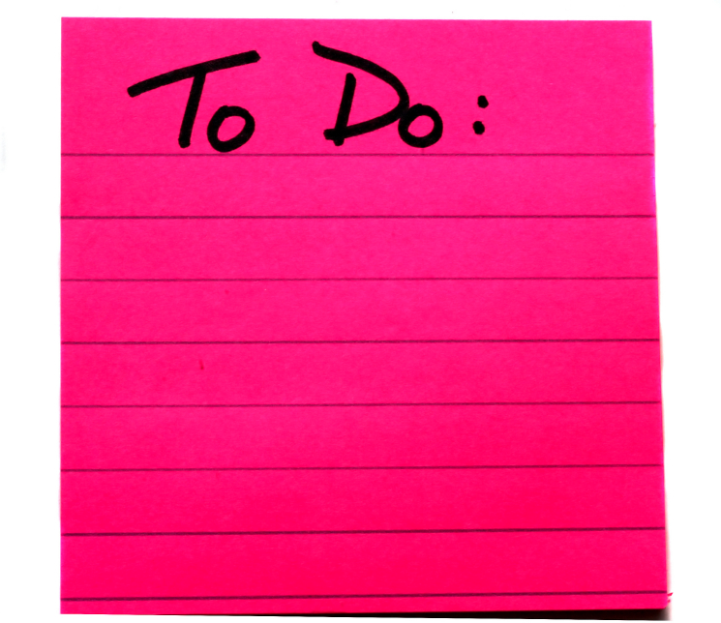

***Young Writer’s Workshop***

***with Deanna Scelzo*:**

**Monday, June 19th**

**1 pm**

**Come expand on your writing interests with this local author, who will offer up helpful tips and ideas. Geared towards school-aged youth.**

***Ladies Library Association Book Sale*:**

**Wednesday, July 19th – Tuesday, July 25th**

**Come one, come all! Books of all genres available for sale. Your book collection needs expanding!**

***Witness the Eclipse*:**

**Monday, August 21st**

**1-3 pm**

**We’ll be celebrating the most ‘lunar-ific’ event of the year, with special viewing sunglasses available for looking extra stylish.**

***Conclusion of Summer Reading Program Pizza Party*:**

**Thursday, August 24th**

**1 pm**

**Participants of our Summer Reading Program will be rewarded with a pizza party for their positive involvement towards “Building a Better World”. Hosted by Honor Credit Union Dowagiac.**

**Special Events**

**Dowagiac District Library**

**Summer Reading Program 2017**

***“Build a Better World”***

**June 16th – August 31st**

**Dowagiac District Library**

**211 Commercial St.**

**Dowagiac, MI 49047**

**#269.782.3826**

**www.dowagiacdl.org**

**The 2017 national Summer Reading Program theme is “Build a Better World”, and we here at the Dowagiac District Library want you to be able to incorporate the importance of protecting our planet with your reading choices while on summer break, all while earning cool prizes along the way for your hard work! Complete a Bingo sheet, turn it in, and earn a “Build a Better World” button (try & collect all 5 designs!). Let your imagination run wild this summer with out-of-this-world reads! Signup for the program at the Circulation or Youth desk. All ages welcome to participate.**

**Weekly Events**

***(June 16th – August 31st)***

***Family Storytime*:**

**Tuesdays, 10:30-11 am**

**Reading selections and activities will reflect the Summer Reading theme “Build a Better World”. Active listening, singing, participation, and crafts are all skills emphasized.**

***Tabletop Games for Adults*:**

**Tuesdays, 5-8 pm**

**Let your inner child out, and strategize over good conversation and board games for some summer fun**

***Game Day*:**

**Thursdays, 3-6 pm**

**Our Xbox makes a weekly appearance for kids aged 9-17, with 30 minute playing increments so everyone gets a turn to play. 4 controllers provided, as well as Xbox games.**

***‘Messy-time’*:**

**Fridays, 11 am**

**Outside (weather permitting)**

**These activities are just too messy for taking on indoors! Each week will feature a new activity pertaining to the “Build a Better World” theme. Be prepared to get your hands (and more!) dirty.**

***Classics Book Discussion*:**

**Saturdays, June 10th & August 12th**

**10:30-11:30 am**

**June discussion: *The Hunchback of Notre Dame***

**August discussion: *Ethan Frome***

**Pick up a free copy of each classic at the circulation desk!**

*“****Build a Better World****”*

**Program**